**NAME: Vaibhav Aggarwal**

**ROLLNO: 2021UIT3043**

**NND LAB PRACTICAL**

**DYNAMIC ROUTING PROTOCOL USING (RIP)**

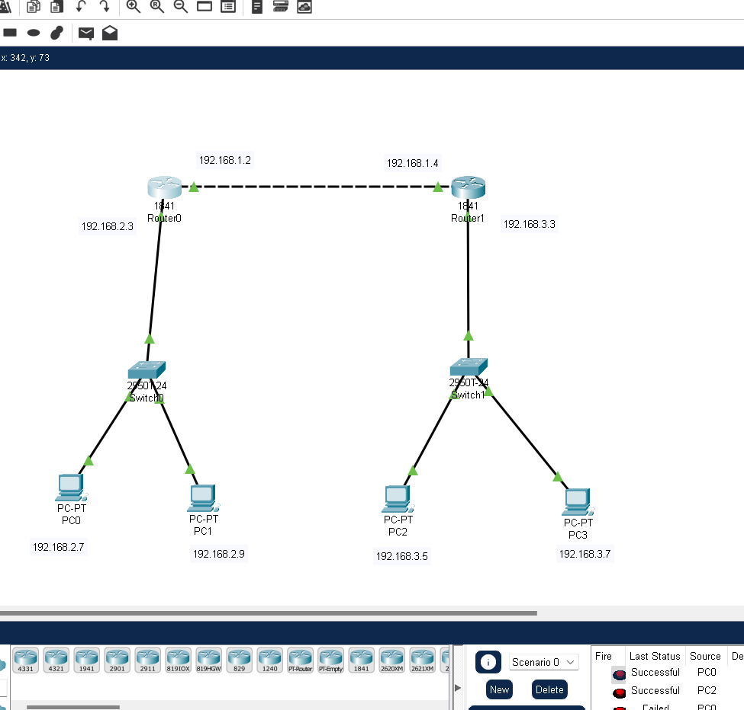

**1.Configure IP adress and subnet mask and default gateway for all PC’s**

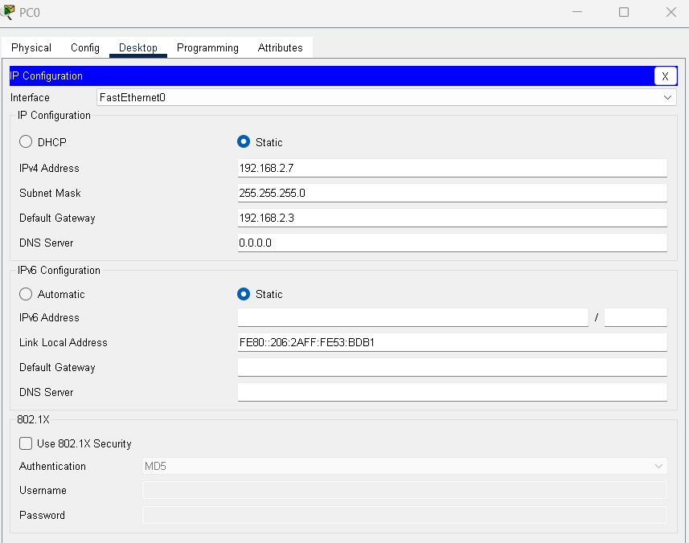

**2.Configure routers with IP adress and subnet mask**

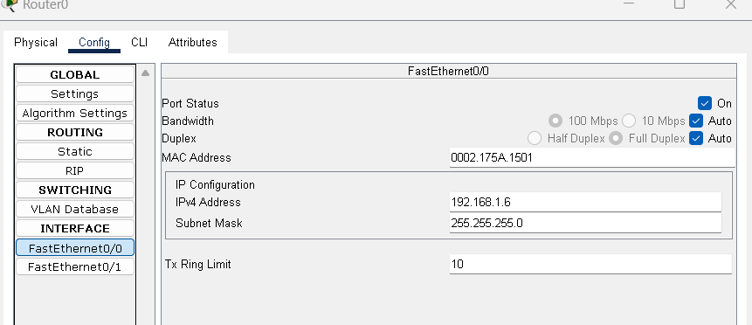

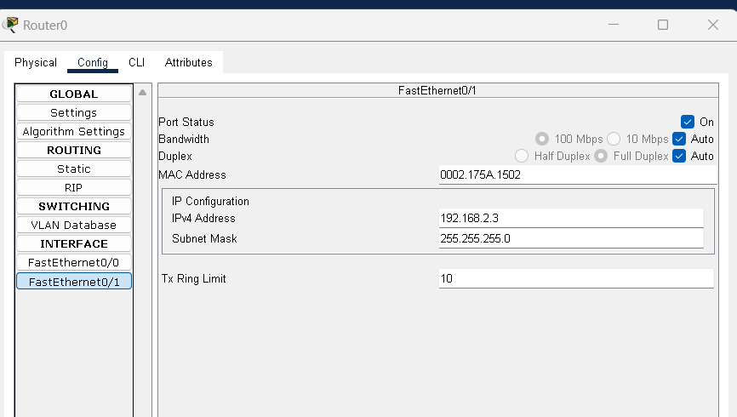

**3.Configure RIP routing algorithm for routers**

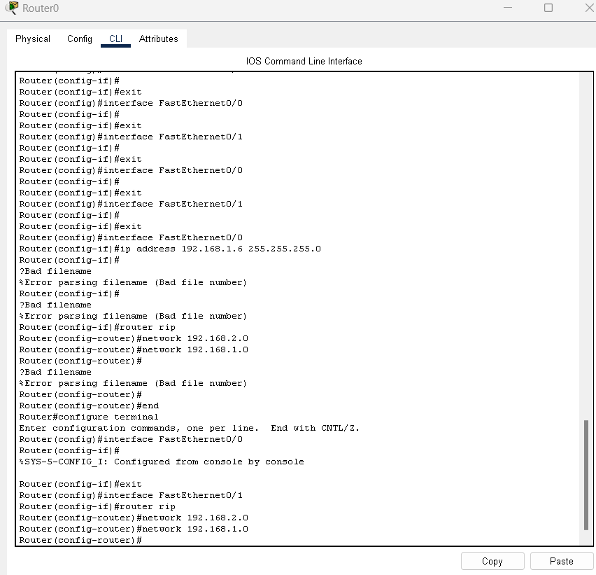

**4. TEST (1)Ping in same network (2)Ping in different network**

